Technical Project

This document relate to user story no. 3 of application requirements(As a Captain I want to send to the First Officer the gate I have chosen so we stay synchronized (8 BP))

1. Screen displays map of Gdańsk's airport. All available gates are displayed on the map using red markers (Figure 1).

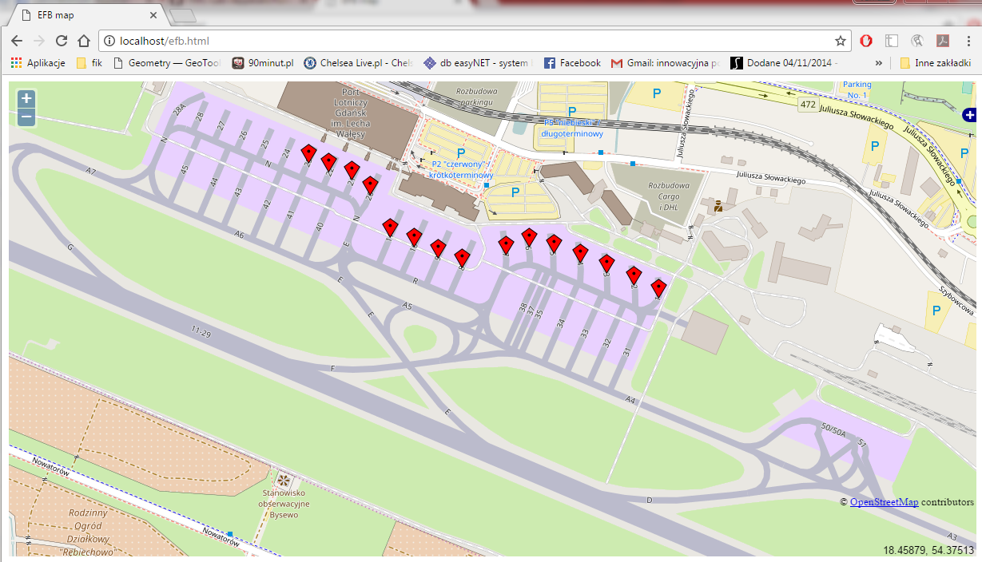

Figure 1

1. To choose the gate in order to set the taxiway Captain should click proper red marker.
2. On the screen appears confirmation button. To confirm the choice click button „Choose gate X”, where X is number of gate.
3. On the screen appears green marker on the chosen gate. Officer screen is synchronized and shows green marker in the same place on the map (Figure 2).

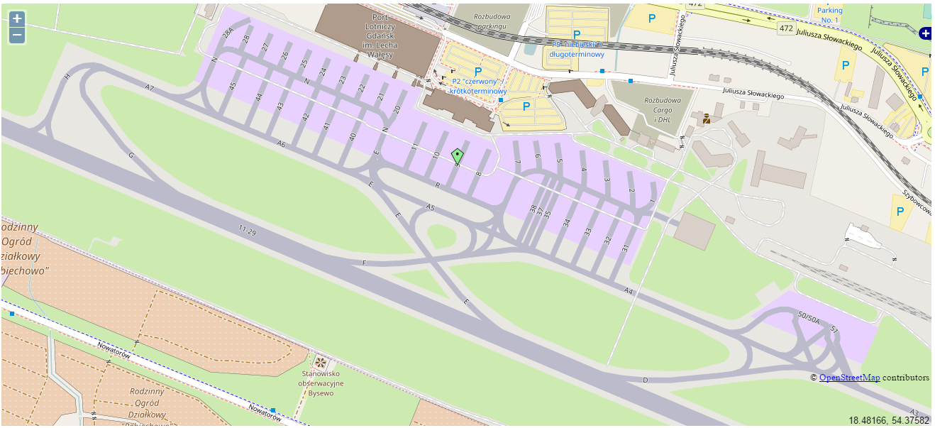

Figure 2

1. Captain has a possibility to change chosen gate.
2. In order to change chosen gate click on green marker. On the screen appears resetting button. To reset operation click button „Reset Gates”, then start screen will appear. Follow points 2 and 3 to mark another gate.